**Fluid Statics**

**Application of the Linear Momentum Principle**

Stress Vector

When we apply the linear momentum principle we need to know the forces acting on the surface of the volume we select. So first, we need to understand stress vectors and related notation.

Stress vector is the force per unit area of the surface at a certain point on the surface. Since it is a vector, it has both magnitude and direction. The direction of the stress vector will depend on the surface or - on the direction of normal to the surface.

Consider a solid bar subjected to a compressive force F. We want to calculate the force acting at point A. However, to define stress vector, we need to define a plane on which this force is acting.

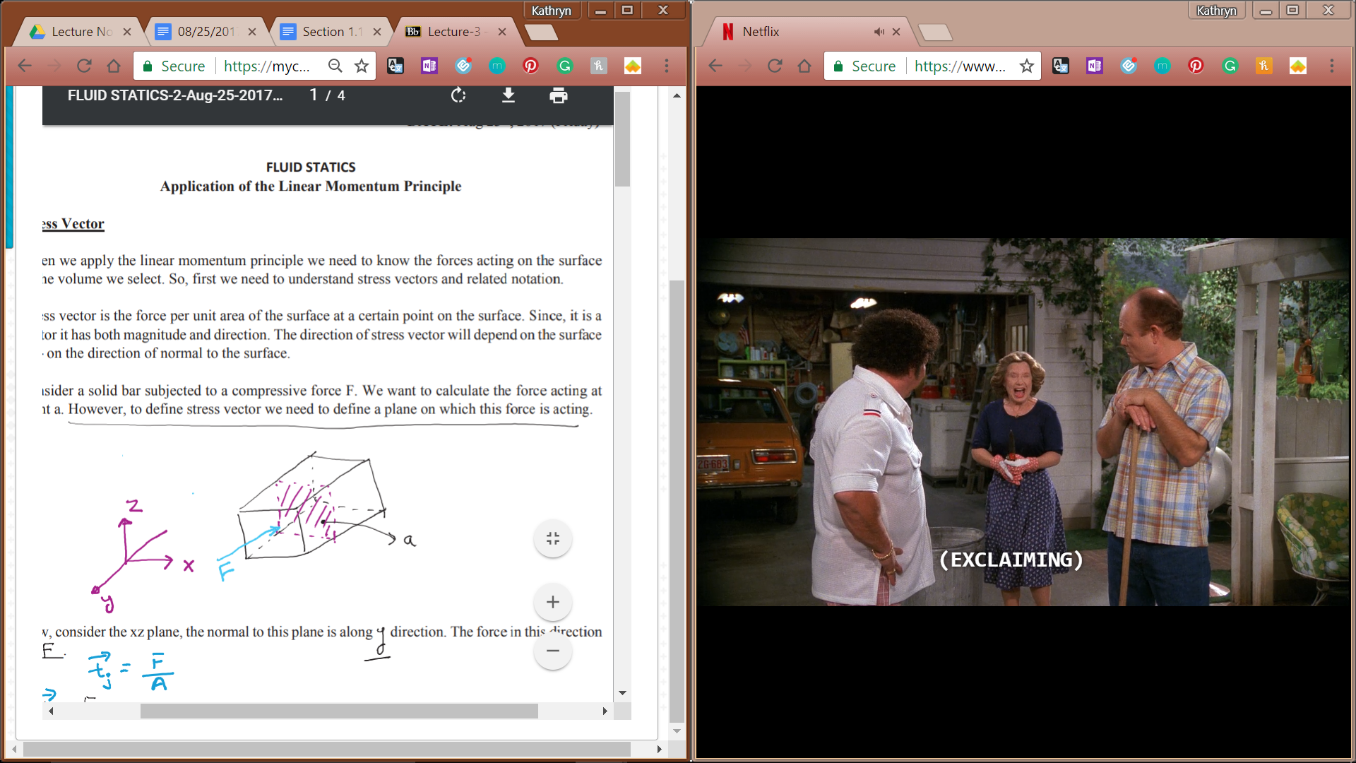

Now, consider the xz plane, the normal to this plane is along the y direction. The force in this direction is **F**.

So, **tj** = **F** / A

Here, the subscript j refers to the normal to the plane (xz) on which the force is acting.

Next, we want stress vector at the same point but acting on the xy plane. The normal to xy plane is z, so the stress vector for this plane is denoted by **tk.**

Question: For the given situation for the bar with compressive force, what is the stress vector for xy plane?

**tk** = 0 (no force acting in this direction)

Normal stress: in the above situation, **tj** is known as normal stress, i.e. stress is acting normal to the plane.

In cases where the forces are NOT normal to the plane, we have two types of stress: shear stress and normal stress. (Referred as normal component of stress and shear component of stress)

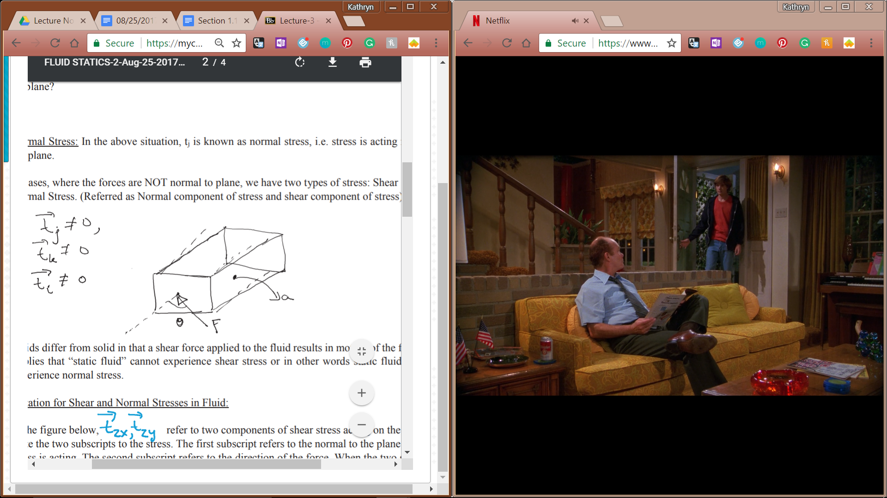

**ti** ≠ 0

**tj** ≠ 0

**tk** ≠ 0

Fluids differ from solid in that a shear force applied to the fluid results in motion of the fluid. This implies that “static fluid” cannot experience shear stress or in other words static fluid can only experience normal stress.

Notation for shear and normal stresses in fluid:

In the figure below, **tzx**, **tzy** refer to two components of shear stress acting on the xy plane. Note the two subscripts to the stress. The first subscript refers to the normal to the plane on which stress is acting. The second subscript refers to the direction of the force. When the two subscripts are not the same, the stress is shear stress. On the other hand, when the two subscripts are the same, the stress is normal stress. For example, **tzz** refers to the force acting along z on the xy plane. The direction of the force and the normal to the plane are the same.

Application of linear momentum principle on static fluid

For a static fluid, the momentum is zero. Therefore, the rate of change of linear momentum is also zero. So the general principle of momentum balance reduces to:

0 = ∫V ⍴**g**dV + ∫A **t**dA

Consider a tetrahedron that is shown below. The forces acting on different planes of the tetrahedron are also shown. It is to be noted that all the forces are normal to the plane on which they are acting since shear stresses are zero for a static fluid. ABCD is the tetrahedron. The four planes of the tetrahedron are ABC, BCD, ADC, and ABD.

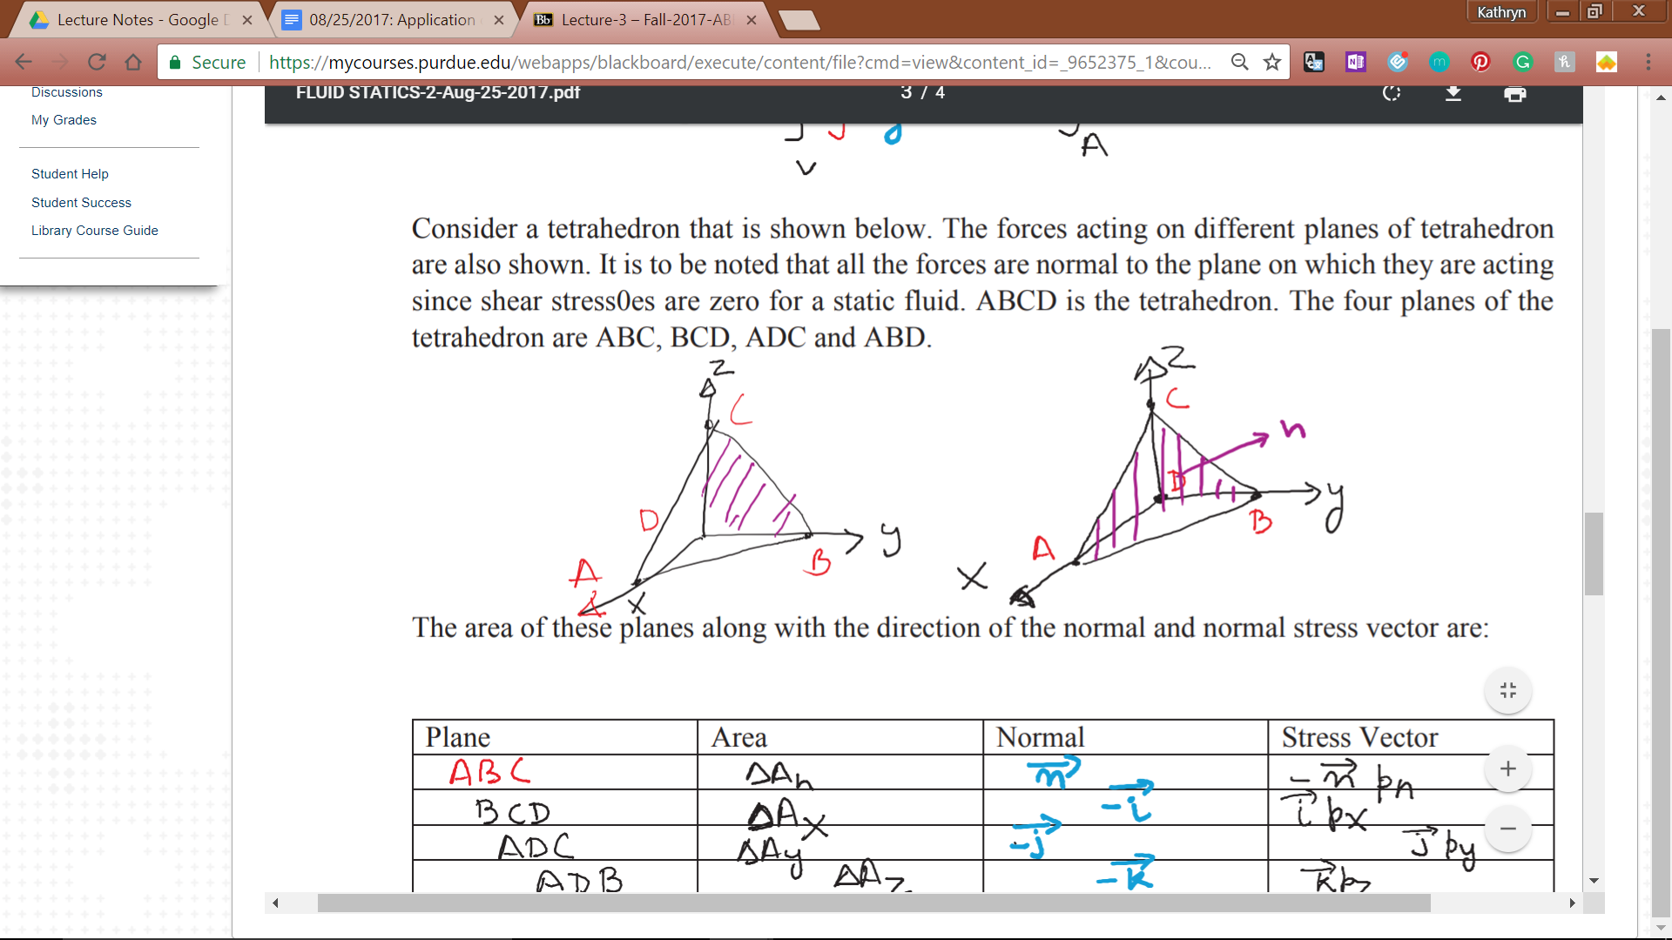

The areas of these planes along with the direction of the normal and normal stress vectors are:

|  |  |  |  |
| --- | --- | --- | --- |
| **Plane** | **Area** | **Normal** | **Stress Vector** |
| ABC | ΔAn | **n** | -**n** * pn |
| BCD | ΔAx | -**i** | **i** * px |
| ADC | ΔAy | -**j** | **j** * py |
| ABD | ΔAz | -**k** | **k** * pz |

0 = ∫V ⍴**g**dV + ∫A **t**dA

0 = ∫V ⍴**g**dV - **n**pnΔAn + **i**pxΔAx + **j**pyΔAy + **k**pzΔAz

Relate Ax, Ay, and Az to An with area projections

ΔAx = ΔAn cos(Θ) = **i** * **n** ΔAn = nx ΔAn **i**

ΔAy = ... = **j** * **n** ΔAn = ny ΔAy **j**

ΔAz = ... = **k** * **n** ΔAn = nz ΔAz **k**

Dot product of the unit vectors and n gives theta.

**n** = **i**nx + **j**ny + **k**nz

0 = ⍴**g**ΔV - **n**pnΔAn + nx**i**pxΔAn + ny**j**pyΔAn + nz**k**pzΔAn

0 = ⍴**g**ΔV/ΔAn - **n**pn + nx**i**px + ny**j**py + nz**k**pz

0 = limΔAn->0 ~~⍴~~**~~g~~**~~ΔV/ΔA~~~~n~~ - **n**pn + nx**i**px + ny**j**py + nz**k**pz

Volume goes to 0 faster, ΔV/ΔAn = 0

0 = **n**pn - [nx**i**px + ny**j**py + nz**k**pz]

0 = [nx**i**pn + ny**j**pn + nz**k**pb] - [nxpx**i** + nypy**j** + nzpz**k**]

0 = nx**i** (pn - px) + ny**j** (pn - py) + nz**k** (pn - pz)

In order to be = 0, each component must = 0, therefore

Pn = px = py = pz